12. Development of HMI screen for the statements

- Figure shows the sketch of a continuous filling operation. This process requires that boxes moving on a conveyor be automatically positioned and filled. The sequence of operation for the continuous filling operation is as follows:
• Start the conveyor when the start button is momentarily pressed.
• Stop the conveyor when the stop button is momentarily pressed.
• Energize the run status light when the process is operating.
• Energize the standby status light when the process is stopped.
• Stop the conveyor when the right edge of the box is first sensed by the photo sensor.
• With the box in position and the conveyor stopped, open the solenoid valve and allow the box to fill. Filling should stop when the level sensor goes true.
• Energize the full light when the box is full. The full light should remain energized until the box is moved clear of the photo sensor.
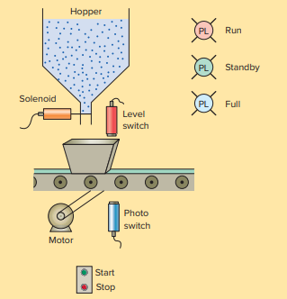

- Show a PLC ladder diagram and HMI screen to operate the fans and lights in a smart room

No.of Persons | Fans | Lights
1-5 | 1 | 1
6-10 | 3 | 3

